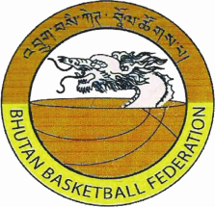

**Bhutan Youth Basketball Camp 2015**

**Registration Form**

Photo

1 No.

Name:………………………………………………………………………………………………………

DOB:……………………………………………………………………………………………………….

Present Address………………………………………………………………………………………..

School……………………………………………………………………………………………………..

Father’s/Mother’s name……………………………………………………………………………………

Occupation/Designation……………………………………………………………………………………

E-mail ID………………………………………………………………………………………………….

I wish to participate in the Bhutan Youth Basketball Camp 2014 and shall participate in the true spirit if sportsmanship abiding by the laws and the rules of the game. In case of my misconduct or ungentle-manly behavior during the camp, the concerned authorities may take necessary action against me.

I am also responsible for my own injuries or accidents that may occur to me during the camp.

Signature of player Signature of Parents/Guardian

Contact No: ……………………………………. Contact No: …………………………………….