DANTAK OPEN MOUNTAIN BIKE RACE 2015
“RACE INFORMATION”

- TITLE OF RACE
-5th DANTAK Open Mountain Bike Race- “Challenge 60-Sixty”
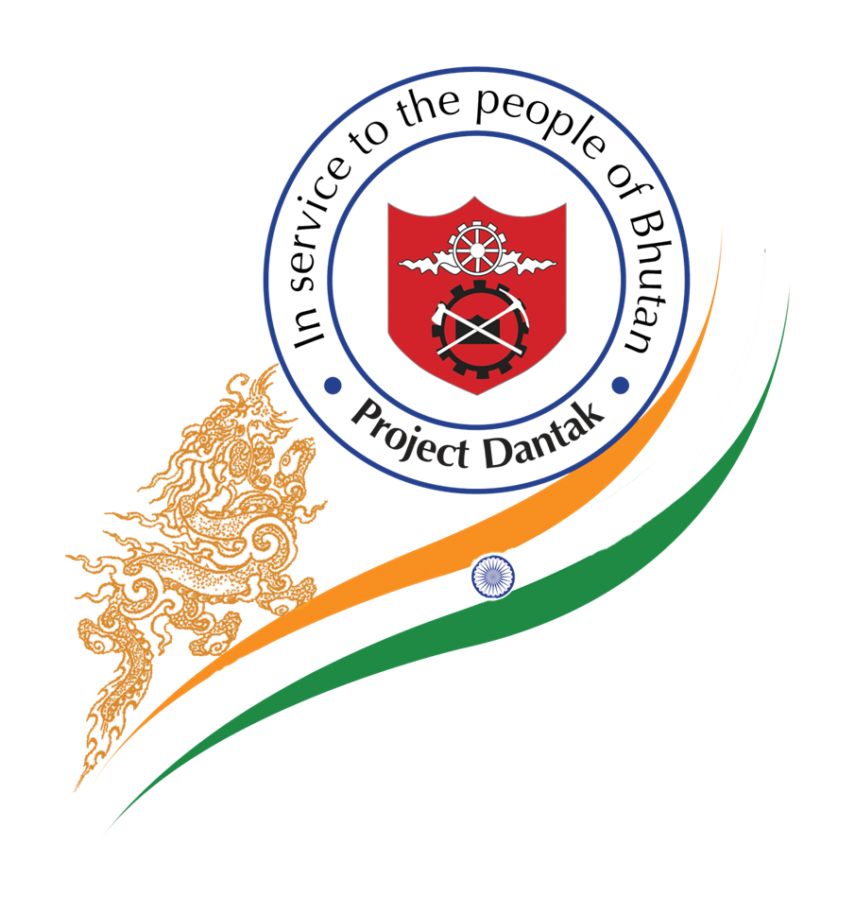
- RACE DATE
-April 19, 2015

- RACE ROUTE
-Changlingmethang Parking, Thimphu (start point) Drugyel, Paro (turning point) Clock Tower Square, Thimphu (finish point)

- ROUTE DISTANCE
Sl. No. | Station |  | Distance (in Kms)
 | From | To
1. | Changlingmethang Parking, Thimphu | Khasadrapchu Aid station | 14.5
2. | Khasadrapchu Aid station | Chuzom Aid Station | 11.2
3. | Chuzom Aid Station | GREF Canteen, Aid Station (Bondey) | 16.0
4. | GREF Canteen, Aid Station (Bondey) | Drugyel, Paro (turning point) | 18.3
5. | Drugyel (turning point) | GREF Canteen, Aid Station (Bondey) | 18.3
6. | GREF Canteen, Aid Station (Bondey) | Chuzom Aid Station | 16.0
7. | Chuzom Aid Station | Khasadrapchu Aid station | 11.2
8. | Khasadrapchu Aid station | Clock Tower Square, Thimphu | 14.5
Total Distance= |  |  | 120.0

- RACE CATEGORY
- Open category (both male and female to be 19 years of age on the day of registration)
- Riders of age 18 years and below are allowed to participate with the legal consent from their parents/guardian.

- REGISTRATION
Note:
1.For National Riders: Please attach a copy of ID or school ID card.
2.For Expats: Please attach a copy of the work permit card.
3. For International Riders: Please attach a copy of passport.
-Registration is open from Monday, March 16, 2015. All cyclist participating in the race must fill in all the details on the registration form. The deadline for registration is: Wednesday, April 15, 2015.

-Riders briefing will be conducted jointly by the DANTAK & BOC officials: Saturday, Apr 18, 2015. Venue: Near Bhutan Tennis Federation’s Office, Changlingmethang National Stadium. The chest numbers will be distributed.

- CYCLING EQUIPMENT
- Mountain Bike
-Only Mountain Bike [26”, 27.5”& 29” wheel dimension and tire size not less than 1.9”] will be allowed to use on race day.

- Helmet
-All participants must have a helmet with proper chin strap. Wearing a rigid safety helmet shall be mandatory during competition.

- Back-up kit
-All participants must carry the following back-up kit:
- Spare tube or a repair kit
- Small portable pump

- CONDUCT OF RIDERS: detailed guidelines attached

- TRANSPORTATION
The personal vehicle is not allowed to assist during the course of the race. If found, then the concerned participant (he/she) shall be disqualified on the spot.

- SUPPORT ON COURSE
- Aid stations
-Aid Station 2: Khasadrapchu
-Aid Station 3: Chuzom
-Aid Station 4: Gref Canteen, Bondey
- Course Marshals at various check points
- Mobile Ambulance: Emergency medical back-ups
- Traffic police & RSTA: Monitor & control traffics
[We recommend all the participants to carry their own water for their own convenience]

- SUPPORT OFF COURSE
- Refreshments at the start (Aid Station 1: Changlingmethang parking, Thimphu) &finish line (Aid Station 5: Clock Tower, Thimphu)

- Race Start Time (Riders shall report at the Changlingmethang parking from 6:00 a.m. onward.)
Race will start at 8:00 a.m. sharp.

- Cut of Time
All the riders should cross Chuzom1:30 p.m. if not they will be picked up by the sweeping team. Any riders who wishes to ride after this time may do so but the organizers shall not be responsible for any inconveniences caused.

- AWARDS (Prizes will be awarded on the same day)
- Cash prizes & Certificates to top 5finishers (both male & female)
- Certificates to finisher participants
- Special prizes to oldest and youngest participants (must complete the race)
- RACE CONTACT DETAILS
For more information about Dantak Open Mountain Bike Race, please contact the following:
- Event Coordinators:
-Capt. Gaurav Kumar,DANTAK- (M) 17560204, (Office Tele) 02-351082
-Tshering Zangmo, BOC- 17608554
-Jigme Thinley, BOC- 17374116

“RACE GUIDELINES”

- General Guidelines
  - DANTAK Open Mountain Bike Race of 120 kms shall be conducted on route Thimphu-Paro-Drugyel-Paro-Thimphu.

  - Briefing and allotment of chest numbers will be conducted jointly by the DANTAK & BOC officials at 1700 hrs on 18 April 2015 at Changlingmethang stadium.

  - All participants will have to report to start point (Changlingmethang Parking area) at 0600 on the race day, 19 April 2015.

  - Final verification and Bike check will be carried out on 19 April 2015, 0600 hrs onwards.

  - Participants are requested to produce the ID in original for final verification.

  - No rider may be on course during the race if he/she has not registered for the race, unless approved by the organizing committee. No other person, without any official responsibility or without the approval of organizing committee may be on the course.

  - The race will start promptly at 0800 hrs.

  - Starting position will be determined by the registration number.

  - Refreshments will be provided at the start point, finish point and in numerous identified aid stations.

  - Participants will be tested for doping banned substances, and must compulsorily provide urine samples, when asked, at either or both the start or finish points.

  - A participant whose test result is positive must promptly return any prizes and primes won in the event.

  - Participants are advised to bring basic repair kits and extra tubes. The organizer shall not be responsible for any loss of time due to technical problems.

  - All riders must use mountain bikes. However, mountain bikes fitted with “sleek tires” that ensure a large contact area on the road, will be entertained. Notwithstanding to above, the approved wheel & tire dimensions for the race are as follows:
- Wheel Size: 26", 27" & 29"
- Tire dimensions: not less than 1.9"

  - Participants will use their own bicycle and all other equipment that the participants feel necessary and organizers will not be responsible in any manner whatsoever for such provisions. Organizers will not be held responsible should such equipment and provisions hinder their participation and efficiency in the race.
  - Participants must finish the race using only one bike. Changing of bikes is not allowed.
  - All the competitors must cross the check points enroute and report to the check point at Drugyel and obtain seal stamp or a token as a proof of having crossed the check point and must retain it till the end of race.
  - The medical back-ups will be stationed at the strategic areas.
  - Participants shall cross Chuzom Check post by 1:30 pm (on the way back), if not they will be picked up by the sweeping team. If the participant wishes to continue, it is at own risk.
  - All participants must produce their chest numbers for availing free meal at the closing ceremony.
  - The awards ceremony will commence at 2:30 p.m. onward.

2. Conduct of Riders
Any misconduct on part of any rider, in breach of any of the guidelines given below, will result in disqualification of the individual from the race as may be decided by the Organizing Committee. The decision of the Organizing Committee will be final and binding.

  - All riders must wear their helmets during the race while they are riding their bicycles. The chin strip must be fastened before the participant first mounts the bicycle, at all times when the participant is on the bicycle, and must not be unfastened until the participant has dismounted.

  - All riders must at all times respect the existing road traffic rules and regulations.

  - All riders shall demonstrate proper sporting sprit and shall, in whatsoever capacity, participate in the race in a fair and sporting manner.

  - No rider shall be disrespectful toward the organizers, officials, other riders or spectators. No rider shall use foul or abusive language or conduct during the race event.

  - Carrying and using glass containers are forbidden during the race.

  - All riders must allow any faster rider to overtake without obstructing such a rider.

  - Participants are requested to not throw their disposal enroute the race.

  - All riders must respect the environment and must make sure that they do not pollute the course venue.

  - All riders may render each other such minor services as lending or exchanging food, drink, spanners or accessories. The lending or exchanging of bicycles are not acceptable.

  - All Riders shall ride with utmost caution. They shall be held responsible for any accidents that they may cause.

  - No rider including, but not limited to, race officials and marshals shall consume alcoholic beverages or any other intoxicants while the race is in progress and any such person who appears to be under the influence of alcohol or other intoxicant shall be promptly relieved of responsibilities/disqualified.

3. Punishable Offenses
The following offenses shall be punishable by disqualification in the current race and suspension from the next edition of the Dantak Open Mountain Bike Race, as may be decided by the organizing committee. The decision of the Organizing Committee will be final and binding:

3.1 The pushing of one rider by another or any sort of physical aggression toward another rider.

  - Intentionally making abrupt motion so as to interfere with the forward progress of another rider. All riders must permit any following or faster rider to overtake without obstructing such a rider.

  - No acts of unsportsmanlike conduct in conjunction with the event will be allowed.

  - Entering the competition under an assumed name or falsifying documentation at the time of registration.

  - Assaulting or committing a violent injury on other rider or official.

  - Pushing or pulling other riders. No rider may hold back or pull an opponent by any part of his/her clothing, equipment or body.

  - Behaviour dangerous to the rider or other competitors.

  - Holding on to a motor vehicle.

  - Failing to ride the entire course, by taking a short cut, riding in a motor vehicle, or by other means.

  - Pulling or pushing another rider or another rider's equipment during a sprint.

  - Fraud or attempted fraud during the race.

4. Results
At the end of the race, results will not be announced until all the checklists are cross-checked and verified by the technical official.

All participants are requested to be present during the prize awarding ceremony.

