DANTAK OPEN MOUNTAIN BIKE RACE - 2015
Route: Thimphu - Paro - Drugyel - Paro – Thimphu
(The 60-Sixty Challenge)
Date: April 19, 2015
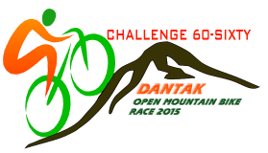
(To be submitted along with registration form)

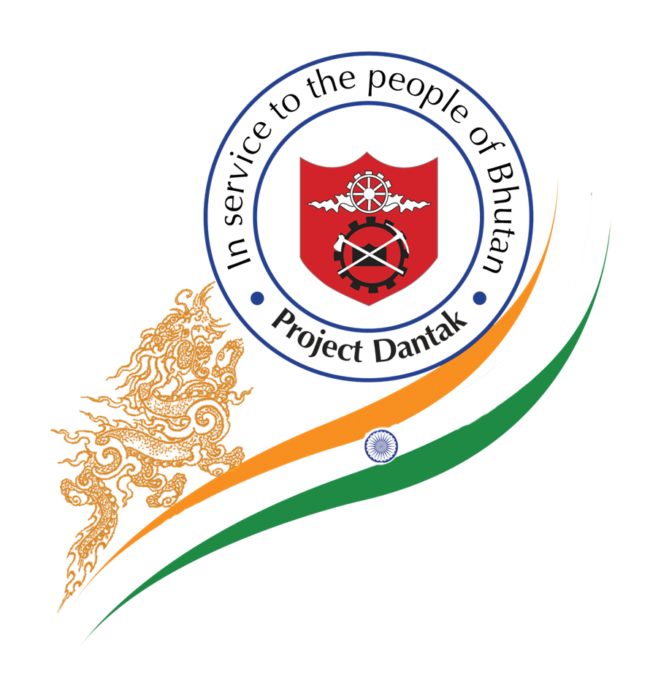

PARTICIPANT: ACCIDENT WAIVER AND RELEASE OF LIABILTY

I acknowledge that this event is an extreme test of a person's physical and mental limits and carries with it the potential for death, serious injury and property loss. The risks include, but are not limited to, those caused by terrain, facilities, temperature, weather, condition of participant, equipment, vehicular traffic, actions of other people including, but not limited to, participants, volunteers, spectators, coaches, event officials, and event monitors, and/or producers of the event, and lack of hydration. These risks are not only inherent to participant, but are also present for volunteers. I hereby assume all of the risks of participating and/or volunteering in this event. I realize that liability may arise from negligence or carelessness on the part of the persons or entities being released, from dangerous or defective equipment or property owned, maintained or controlled by them or because of their possible liability without fault.

I certify that I am physically fit, have sufficiently trained for participation in the event and have not been advised otherwise by a qualified medical person.

I acknowledge that this Accident Waiver and Release of Liability form will be used by the event holders, sponsors and organizers, in which I may participate and that it will govern my actions and responsibilities at said events. In consideration of my application and permitting me to participate in this event, I hereby take action for myself, my executors, administrators, heirs, next of kin, successors, and assigns as follows : (A) Waive, Release and Discharge from any and all liability for my death, disability, personal injury, property damage, property theft or actions of any kind which may hereafter accrue to me including my traveling to and from this event, including but not limited to the following entities or person : DANTAK. Their directors, officers, employees, volunteers, representatives, and agents, the event holders, event sponsors, event volunteers; (B) Indemnify and Hold Harmless the entities or persons mentioned in this paragraph from any and all liabilities or claims made as a result of participation in this event, whether cause by the negligence of releases or otherwise.

I hereby consent to receive medical treatment that may be deemed advisable in the event of injury, accident, and/or illness during this event.

I understand that at this event or related activities, I may be photographed. I GRANT to Event organizers and their licensees the right, permission and authority to use my name, voice, picture or photograph, in any broadcast, telecast, commercial advertisement, promotion, or other account of an Event, and I WAIVE any rights to future compensation to which I might otherwise have been entitled for such use. The Accident Waiver and Release of Liability shall be construed broadly to provide a release and waiver to the maximum extent permissible under applicable law.

I hereby certify that I have read this document; I understand its content.

PARENT OR GUARDIAN WAIVER FOR MINORS (Under 18 years old)
The undersigned parent and natural guardian does hereby represent that he/she is, in fact, acting in such capacity and agrees to save and hold harmless and indemnify each and all of the parties referred to above from all liability, loss, cost, claim or damage whatsoever which may be imposed upon said parties because of any defect in or lack of such capacity to so act and release said parties on behalf of the minor and the parents or legal guardian.

MINOR'S ASSUMPTION OF RISK
I have discussed the event that I wish to participate in with my parents or legal guardians, and they have explained to me the possibility of my being injured. I know that I could be injured, possibly severe or even worse. I am willing to assume the responsibility of this in order to be a participant in the event that I wish to participate in. I also agree that at any point, if I feel endangered either by my own actions or those of others, that I am free to withdraw from the event and will do so of my own free will. I know that I am not giving up any of my rights and that it is ok for me to participate. I HAVE READ THE ABOVE ASSUMPTION OF RISK. I FULLY UNDERSTAND WHAT IT MEANS AND HAVE SIGNED IT VOLUNTARILY.

Name, Age, Signature of participant, Date

DANTAK OPEN MOUNTAIN BIKE RACE - 2015
(REGISTRATION FORM)

- First Name: ________________________________ Middle Name: ___________________________

Last Name: ___________________________________ (IN BLOCK LETTER)

- Father's Name: ______________________________

- Gender: M / F

- Date of Birth: Day____________ Month ___________ Year_________________

- Age (as on 19 Apr 2015):

- Nationality: __________________________________

- Citizenship I.D. No/Passport No. (If Foreigner): _________________________________________

- Address: ______________________________________________________________________

- Mobile No.:_________________ Office No: ______________ Residence No: ________________

- E-mail Address: __________________________________________________________________

- Emergency Contact Person (with Mobile/Tele No.): ______________________________________

* Any changes in the conduct of the Race/Timing shall be informed to the participants at above email/phone number.

**It is mandatory for Participants to attach a photocopy of Identity Proof.
Following IDs will be accepted.

For Bhutan Nationals: For Foreign Nationals:

1. Citizenship ID copy 1. Work Permit Card copy
2. School ID (if below the age of 18 years) 2. Passport copy
For Official use only:
Approved for participation: [Yes][No]
Name and designation of approving authority: _______________

Signature: ______________________

